# 5 - Discussion

## 5.1 - Previous Experience

18 participants were involved in the study, this was subdivided by two factors, gaming experience and musicianship. With the majority being gamers (Figure X) and non-musicians (Figure X) respectively, however when these groups are combined the largest group was people who are both a gamer and a musician, at ~39%, closely followed by people who were neither, at ~33% (Figure X). As the number of participants is relatively low it cannot be stated if this is an actual causal relationship or a statistical anomaly, although this would be an interesting field of research. It is noted however that further correlation between gamers and musicians will be influenced by this.

An immediate difference shown from the musical experience, was that 50% or musicians mentioned tonal differences in their answers (i.e. the valence controlled changes), while only 25% of non-musicians. This may be due to the fact that musicians have a larger knowledge base of music theory, as it is an integral part of learning to play an instrument.

Another difference between musical experience came from the fact that some of the in-game events have associated diegetic sound effects which caused some of the participants to incorrectly say that said event was effecting the music. For example, for being close to a laser grid one participant answered that they “*Could here the sizzle of the laser*”. Or when using the teleporters another said “*There was a sound effect attached to moving through it*”, and when seen by the cameras, “*sometimes added a "motion detected"* ”, incorrectly ascribing the guards sound effects, or the dialogue prompt when the lights turn orange, to the camera seeing them.

The questionnaire also found that the clear majority of participants agreed that music that changed with the events of a game to be important (~94%), put this area of research in a favourable light as a subject that would need to continue.

## 5.2 - Descriptions of the Music

At the start of the game the intensity and valence are both set to be neutral levels (both are around zero), the resultant music would then be neutral in terms of its emotional state. This was supported by the even spread of the answers when participants were asked to describe this (shown in Figure X), the sad description was the only option that was not chosen. Interestingly, there was a clear divide between the gaming experience, as gamers choose emotions with lower intensity (happy, relaxing, and boring), while non gamers also chose the higher intensity choices (exciting and stressful), this was attributed to the fact that gamers have more experience with stressful games and so would not find the start of the game as stressful, as it was the easiest part of the game.

The two groups were in more of agreement when describing the music for the next three questions. When the lights changed to orange, which marks the half way point of the game, almost two thirds of participants described the music as exciting which lines up with the in game circumplex graph

IMAGE OF IN GAME CIRCUMPLEX

This also correlation with the in-game circumplex when the lights turn red and when the player were being chased by the guards as the almost all the participants described these events as either stressful or exciting, with the majority choosing stressful (~70% for both).

## 5.2 - Musical Related Events

A shown in Figure X ~41% of participant’s correctly identified the events that had an effect, however ~33% of answers were unsure. The events which caused the most doubt were; being seen by a security camera, being close to a guard, and being inside a secret path, and when talking to the participants these three events were also brought up as the most confusing for them.

For being seen by the security cameras, it made sense to the participant that as the guards seeing them had an obvious effect (~78% of participants answered yes) then it would follow that the cameras seeing them would also have an effect (~38% of participants thought this to be the case).

The fact that the proximity to a guard was calculated using the Pythagorean distance between the guards and the player, it then did not take into account the shape of the map. A participant could be very close to a guard (according to the application), but the distance the guard would have to travel to reach the player could be much higher, as shown below in Figure X.

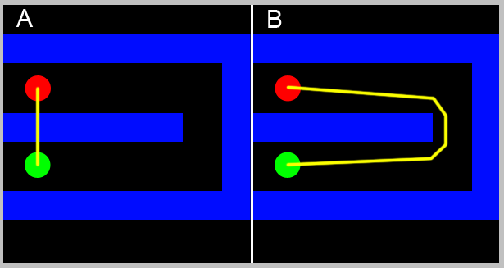

Figure 1: Shows the difference between what the application would use to calculate how close a guard was to the player (A), and how close the guard is in walking distance (B).

And for the secret passage ways, this is most likely a result of the player’s speed effecting the music. As the majority of player’s, that were observed, did not change their speed for most of the game this caused the lack of a clear answer for the speed. However, the one place participants did consistency change speed was in the secret passage ways, this was either to allow them to easily navigate through the smaller passageways, or to let a guard pass by.

On interesting difference between subgroups occurred when the participants were asked if the players score had an effect on the music. While the majority (~55%) correctly said that it did have an effect on the music, this was almost entirely made up of the gamers, ~82% of gamers answered yes, while the majority of non-gamers answered not sure (~71%). This is most likely due to games having a heavy focus on getting a high score, and so gamers would be more attuned to this having a positive effect on the music.

Another point of note is that initially the teleport event was defined as an event which had no effect on the music, while this is technically true using the teleporter does directly affect either the intensity or the valence, using the teleporter will change the player’s position relative to the guards and so the proximity to guards will change, thus changing the music

## 5.3 - Problems

### 5.3.2 - 1st Order Markov

One of the main issues with the project was that only a 1st order Markov chain was implemented, this did not distinguish the music enough from purely random generation if the data set it was given too long, similar to the problem of adding to many rest (discussed above, see section XX) to much variability in the inputted song causes each state to have to many possible next states. Following on from this the song that was used had to much pitch variation, as each section of the song contained at least one 0.5 beat rest, the generated melody could jump between high and low sections. This was noticed by some of the participants, one noted there was a ‘*high pitched off key series of notes*”, when a guard saw them, even though the change in the game state would not specifically cause this effect, the application is then benefiting from humans ability to see patterns in places there is not [REFERENCE], although as stated this effect was not a deliberate one and so did not have the consistency to have a specific cause and effect, as shown by another participant who wrote “*…other parts (like the really high notes) seemed to come out of nowhere*”.